Autism Explorers – Terms & Conditions

Autism Explorers CIC

Supervision & Responsibility Policy
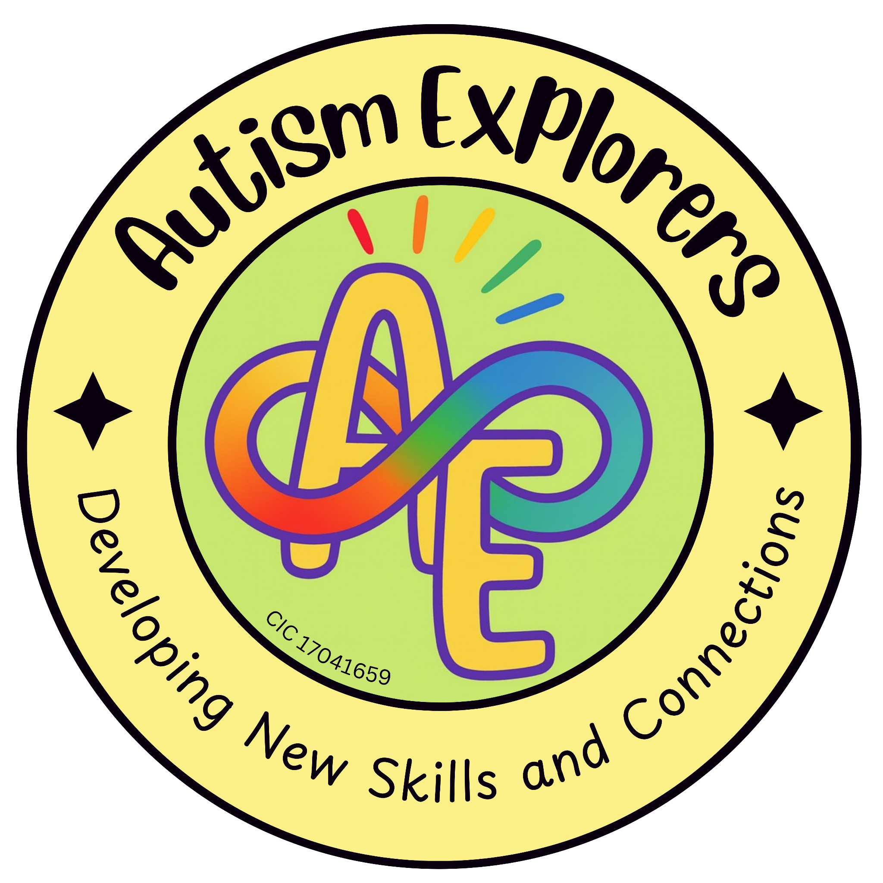

Autism Explorers CIC
Supervision & Responsibility

Autism Explorers CIC is a community group within Norfolk providing support for children with SEND and their families through; regular provisions and services such as, Sensory Saturday Stay & Plays that are child-led play, inclusive trips, events and workshops.

Supervision & Responsibility:

Our Statement:

For all of our provisions and services, unless stated otherwise parents and carers must accompany their child at all times. Furthermore, parents and carers remain responsible for their child's behaviour, actions, safety and well-being for the duration of the provision and service.

Autism Explorers CIC will do everything reasonable to keep the child safe, however we cannot accept liability for accidents or incidents that occur due to lack of supervision by parents and carers. Risk assessments are done during the planning process, as well as the morning of provision and service taking place.

Responsibility:

Parents and carers are responsible for ensuring that the provisions, sessions, or activities they book are suitable for their child’s age, abilities, needs, and level of support required. This helps ensure that children can participate safely and benefit from the activities provided.

Autism Explorers CIC aims to provide a safe, inclusive, and supportive environment for all participants. Children are expected to follow reasonable safety guidance and instructions given by team members during sessions and activities.

Outdoor Play and Activities:

May take place during our provisions and sessions where appropriate, however, these are dependent on weather conditions. Parents and carers are kindly asked that children are dressed appropriately for the weather and suitable for outdoor activities.

Food & Drink:

Parents and carers are responsible for informing Autism Explorers CIC of any food allergies, intolerances or dietary requirements their child may have. Where children bring their own food or snacks, parents and carers must ensure these are appropriate and safe for their child.

Drinks and snacks provided by Autism Explorers CIC during provisions and sessions, will be appropriate for children. However, Autism Explorers CIC cannot guarantee a completely allergen-free environment.

Clothing and Personal Belongings:

Children should attend sessions wearing appropriate clothing and footwear for both indoor and outdoor activities. This may include weather-appropriate clothing such as coats, waterproofs, sun hats, or warm layers depending on the season.

Autism Explorers CIC cannot accept responsibility for lost, damaged, or misplaced personal belongings, so we recommend that valuable items are not brought to sessions.

Responsibility within Health & Safety:

Parents and carers are responsible for informing a member of the Autism Explorers CIC team if their child has specific needs that may require reasonable adjustment.

‘Resources and equipment have been carefully chosen by the Autism Explorers CIC team members for safety and suitability. Should your child have specific needs that may require reasonable adjustments please let us know at your earliest convenience.’ - Quoted from the Autism Explorers CIC: Health & Safety Policy, last updated in March 2026.

Parents and carers are responsible for informing a member of the Autism Explorers CIC team if their child has a medical condition and any relevant medication.

‘Parents and carers responsible for the child must inform a first aid trained Autism Explorers CIC team member upon arrival to the provisions and sessions if their child has any medical conditions. This ensures that the appropriate first aid can be administered and assistance with medication can be provided if necessary.’ - Quoted from the Autism Explorers CIC: Health & Safety Policy, last updated in March 2026.

Parents and carers are responsible for ensuring that their child is well enough to participate, and being mindful of their symptoms.

‘Autism Explorers CIC kindly asks that any child showing signs of sickness or illness (e.g. fever, vomiting, diarrhoea, etc.) does not attend their booked/scheduled provision and session. This helps to reduce the risk of or prevent the spread of sickness or illness to the other children, parents, carers and team members.

Some of the children who attend our provisions and services may have underlying medical conditions or a weakened immune system, which can make them more vulnerable to infections. For this we ask families to be mindful of symptoms and only attend provisions and sessions when children are well enough to participate.’ - Quoted from the Autism Explorers CIC: Health & Safety Policy, last updated in March 2026.

Parents and carers must provide up-to-date emergency contact information relevant to their child.

Changes to our Terms and Conditions & All Other Policies
Autism Explorers CIC reserves the right to change, amend and update our terms and conditions and policies at any time.

The latest versions of all our policies will be available on our website: https://www.autismexplorersnorwich.com/ or can be sent via email with written request: helloautismexplorers@gmail.com

By booking and using our services you are agreeing to our terms and conditions.

Contact Information
Email: | Telephone:
helloautismexplorers@gmail.com | 07557220309

