Autism Explorers – Terms & Conditions

Autism Explorers CIC

Intellectual Property Rights & Copyright Policy

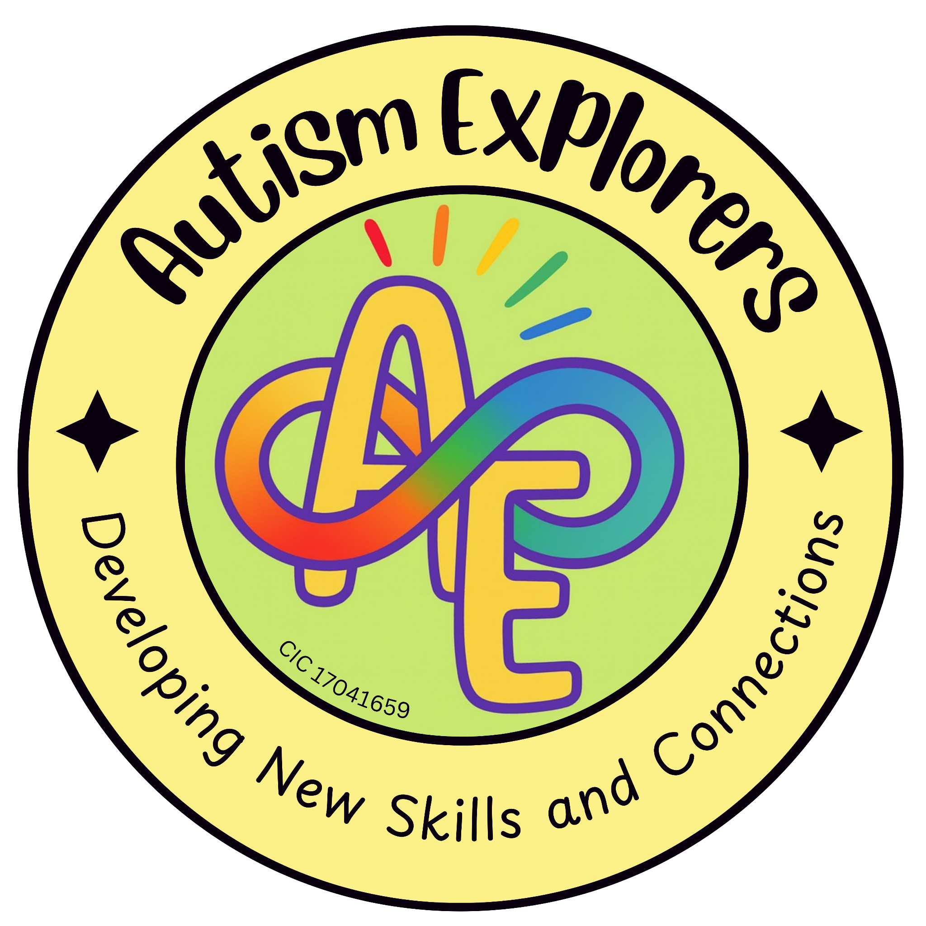

Autism Explorers CIC
Intellectual Property Rights & Copyright

Autism Explorers CIC is a community group within Norfolk providing support for children with SEND and their families through; regular provisions and services such as, Sensory Saturday Stay & Plays that are child-led play, inclusive trips, events and workshops.

Intellectual Property Rights & Copyright:

All content created by Autism Explorers CIC, including but not limited to resources, written materials, activity plans, website content, newsletters, logos, graphics, flyers, posters, leaflets, images, and videos, is protected under the Copyright, Designs and Patents Act 1988.

Unless stated otherwise in writing, all intellectual property rights belong solely to Autism Explorers CIC.

Permitted Use:

You may view, share, and use Autism Explorers CIC materials for personal or educational purposes only (e.g. gaining inspiration from a Sensory Saturday activity to use at home or in a school setting, provided credit is given to Autism Explorers CIC).

Prohibited Use:

You may not copy, reproduce, or redistribute our materials, resources, or branding for commercial use or financial gain without prior written consent and formal approval from Autism Explorers CIC.

Brand Protection:

The use of the Autism Explorers CIC name, logo, or brand identity for advertising, training, or services not officially associated with our organisation is strictly prohibited.

Requesting Permission:

If you wish to use any Autism Explorers resources or media for purposes outside of "Permitted Use," you must contact us in writing via email to request formal approval.

Changes to our Terms and Conditions & Policies

Autism Explorers reserves the right to change, amend and update our terms and conditions and policies at any time.

The latest versions will always be available on our website https://www.autismexplorersnorwich.com/ or by written request via email.

By booking and using our services you are agreeing to our terms and conditions.

Contact Information
Email: | Telephone:
helloautismexplorers@gmail.com | 07557220309

