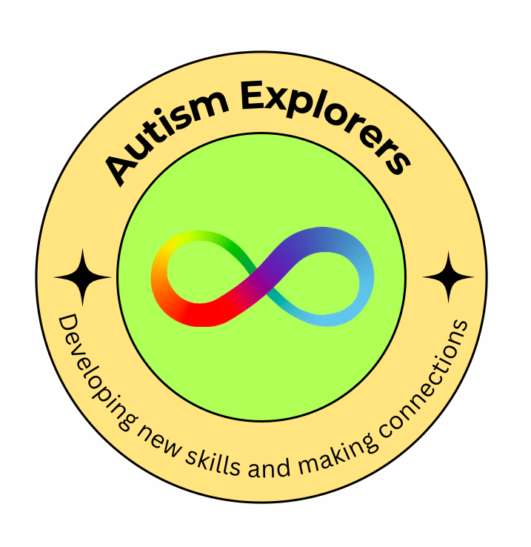
Autism Explorers – Health and Safety Policy
Location: Carrow House
Age Group: 3–12 Years
Last Reviewed: 27/04/2025
Next Review Due: 27/05/2025

1. Policy Statement
Autism Explorers is committed to ensuring the health, safety, and welfare of all children, staff, volunteers, and visitors at Carrow House. We are dedicated to creating a safe and supportive environment where children with autism and additional needs can participate in activities and learn, free from harm or injury. This policy sets out the health and safety procedures that all staff, volunteers, and visitors must follow to ensure the safe operation of all activities.

2. Responsibilities

2.1 Staff and Volunteers
- Responsibility for Health and Safety: All staff and volunteers must ensure that they are aware of and comply with the health and safety procedures in place at Autism Explorers.
- Duty of Care: Staff and volunteers are responsible for ensuring that children are safely supervised at all times, especially during activities, breaks, and transitions between areas.
- Training: All staff and volunteers are required to undergo regular health and safety training, including first aid training and training on autism-specific needs and behaviours.
- Reporting Hazards: Staff and volunteers must report any hazards, accidents, or safety concerns immediately to the designated Health and Safety Officer or the Designated Safeguarding Lead (DSL).

2.2 Health and Safety Officer
- Role: The Health and Safety Officer (or equivalent staff member) is responsible for ensuring that all health and safety regulations are implemented and followed. This includes conducting risk assessments, maintaining safety equipment, and keeping records of accidents and incidents.

3. Health and Safety Procedures

3.1 Risk Assessments
- Pre-Session Risk Assessments: A thorough risk assessment is carried out before each session to identify and address any potential hazards. This includes assessing the environment (indoor and outdoor spaces) and the activities planned for the day.
- Ongoing Risk Assessments: Risk assessments are revisited during sessions, particularly when any changes to the activity, weather, or group dynamics occur.
- Special Needs Consideration: When planning sessions, specific health and safety considerations for children with autism or other additional needs are taken into account.

3.2 Emergency Procedures
- Fire Safety: Fire exits and evacuation routes must always be kept clear. Fire drills are conducted regularly, and children and staff are instructed on fire safety procedures.
- Emergency Contacts: Parents and guardians must provide up-to-date emergency contact information. In case of an emergency, staff will attempt to contact parents/guardians immediately.
- First Aid: First aid kits are available at all times. A qualified first aider will be on-site during all sessions. In the event of an injury, first aid will be administered, and the appropriate medical service will be contacted if necessary.
- Evacuation Procedures: Staff will guide children to a designated safe meeting point if an evacuation is necessary. Headcounts will be performed to ensure no one is left behind.

3.3 Hygiene and Cleanliness
- Sanitation: All areas will be kept clean and free from hazards, with a particular focus on hygiene in shared spaces and activity areas. This includes ensuring clean and accessible toilet facilities for all children.
- Handwashing: Children are encouraged and reminded to wash their hands regularly, particularly before meals and after outdoor play.
- Illness: Children showing signs of illness (e.g., fever, vomiting, diarrhoea) will be sent home to reduce the risk of spreading illness. A staff member will contact the child’s parent or guardian immediately.

4. Supervision and Behaviour Management

4.1 Supervision
- Children must be supervised at all times. A minimum of two staff members will be present for each group of children.
- Staff will remain with children during transitions between activities and breaks to ensure their safety at all times.
- A headcount will be conducted regularly, especially during transitions, outdoor activities, and before the end of each session.

4.2 Behaviour Management
- Positive behaviour strategies are used to support children with autism and other additional needs. Staff will always aim to use calm, clear communication and give children space when needed.
- Physical intervention: Physical intervention will only be used when absolutely necessary to prevent harm to the child or others (e.g., in emergency situations).
- Behaviour Support Plans: If needed, individual behaviour support plans will be developed for children with specific needs. These plans will be communicated to all staff and volunteers involved.

5. Health and Safety in Specific Activities
- Outdoor Activities: Risk assessments will be carried out for outdoor sessions (e.g., forest schools, trips), considering weather conditions, terrain, and supervision levels.
- Equipment: All activity equipment will be checked regularly to ensure it is safe and appropriate for the children’s use. Any broken or unsafe equipment will be removed immediately.
- Specialised Needs: For children with additional needs, staff will adapt activities to meet their specific health and safety requirements (e.g., additional support with mobility, sensory considerations).

6. Reporting Accidents and Incidents
- Accidents and injuries: All accidents or injuries (however minor) must be reported immediately. A record will be kept of the incident, including details of what happened and the actions taken.
- Incident Forms: Incident report forms will be completed and reviewed by the Health and Safety Officer. If required, the relevant authorities (e.g., local safeguarding board, Ofsted) will be notified.
- Parents Informed: Parents or guardians will be informed of any accidents or injuries involving their child as soon as possible.

7. First Aid and Medical Care
- First Aid Kits: First aid kits are kept on-site and checked regularly. They include essential supplies for minor injuries.
- Medical Records: Parents or guardians must inform staff of any medical conditions or medications their child may require during the sessions.
- Emergency Medical Assistance: In the event of a medical emergency, the child will be taken to the nearest hospital, and the child’s parents will be notified.

8. Policy Review and Monitoring
This Health and Safety Policy will be reviewed annually or in response to any significant incidents. Feedback from staff, parents, and children will be considered to ensure the ongoing safety and improvement of Autism Explorers.

Signed by: LFORSTER
Position: FOUNDER
Date: 27/04/2025

