Autism Explorers – Terms & Conditions

Autism Explorers CIC

Understanding and Support for
All Children and Families Policy

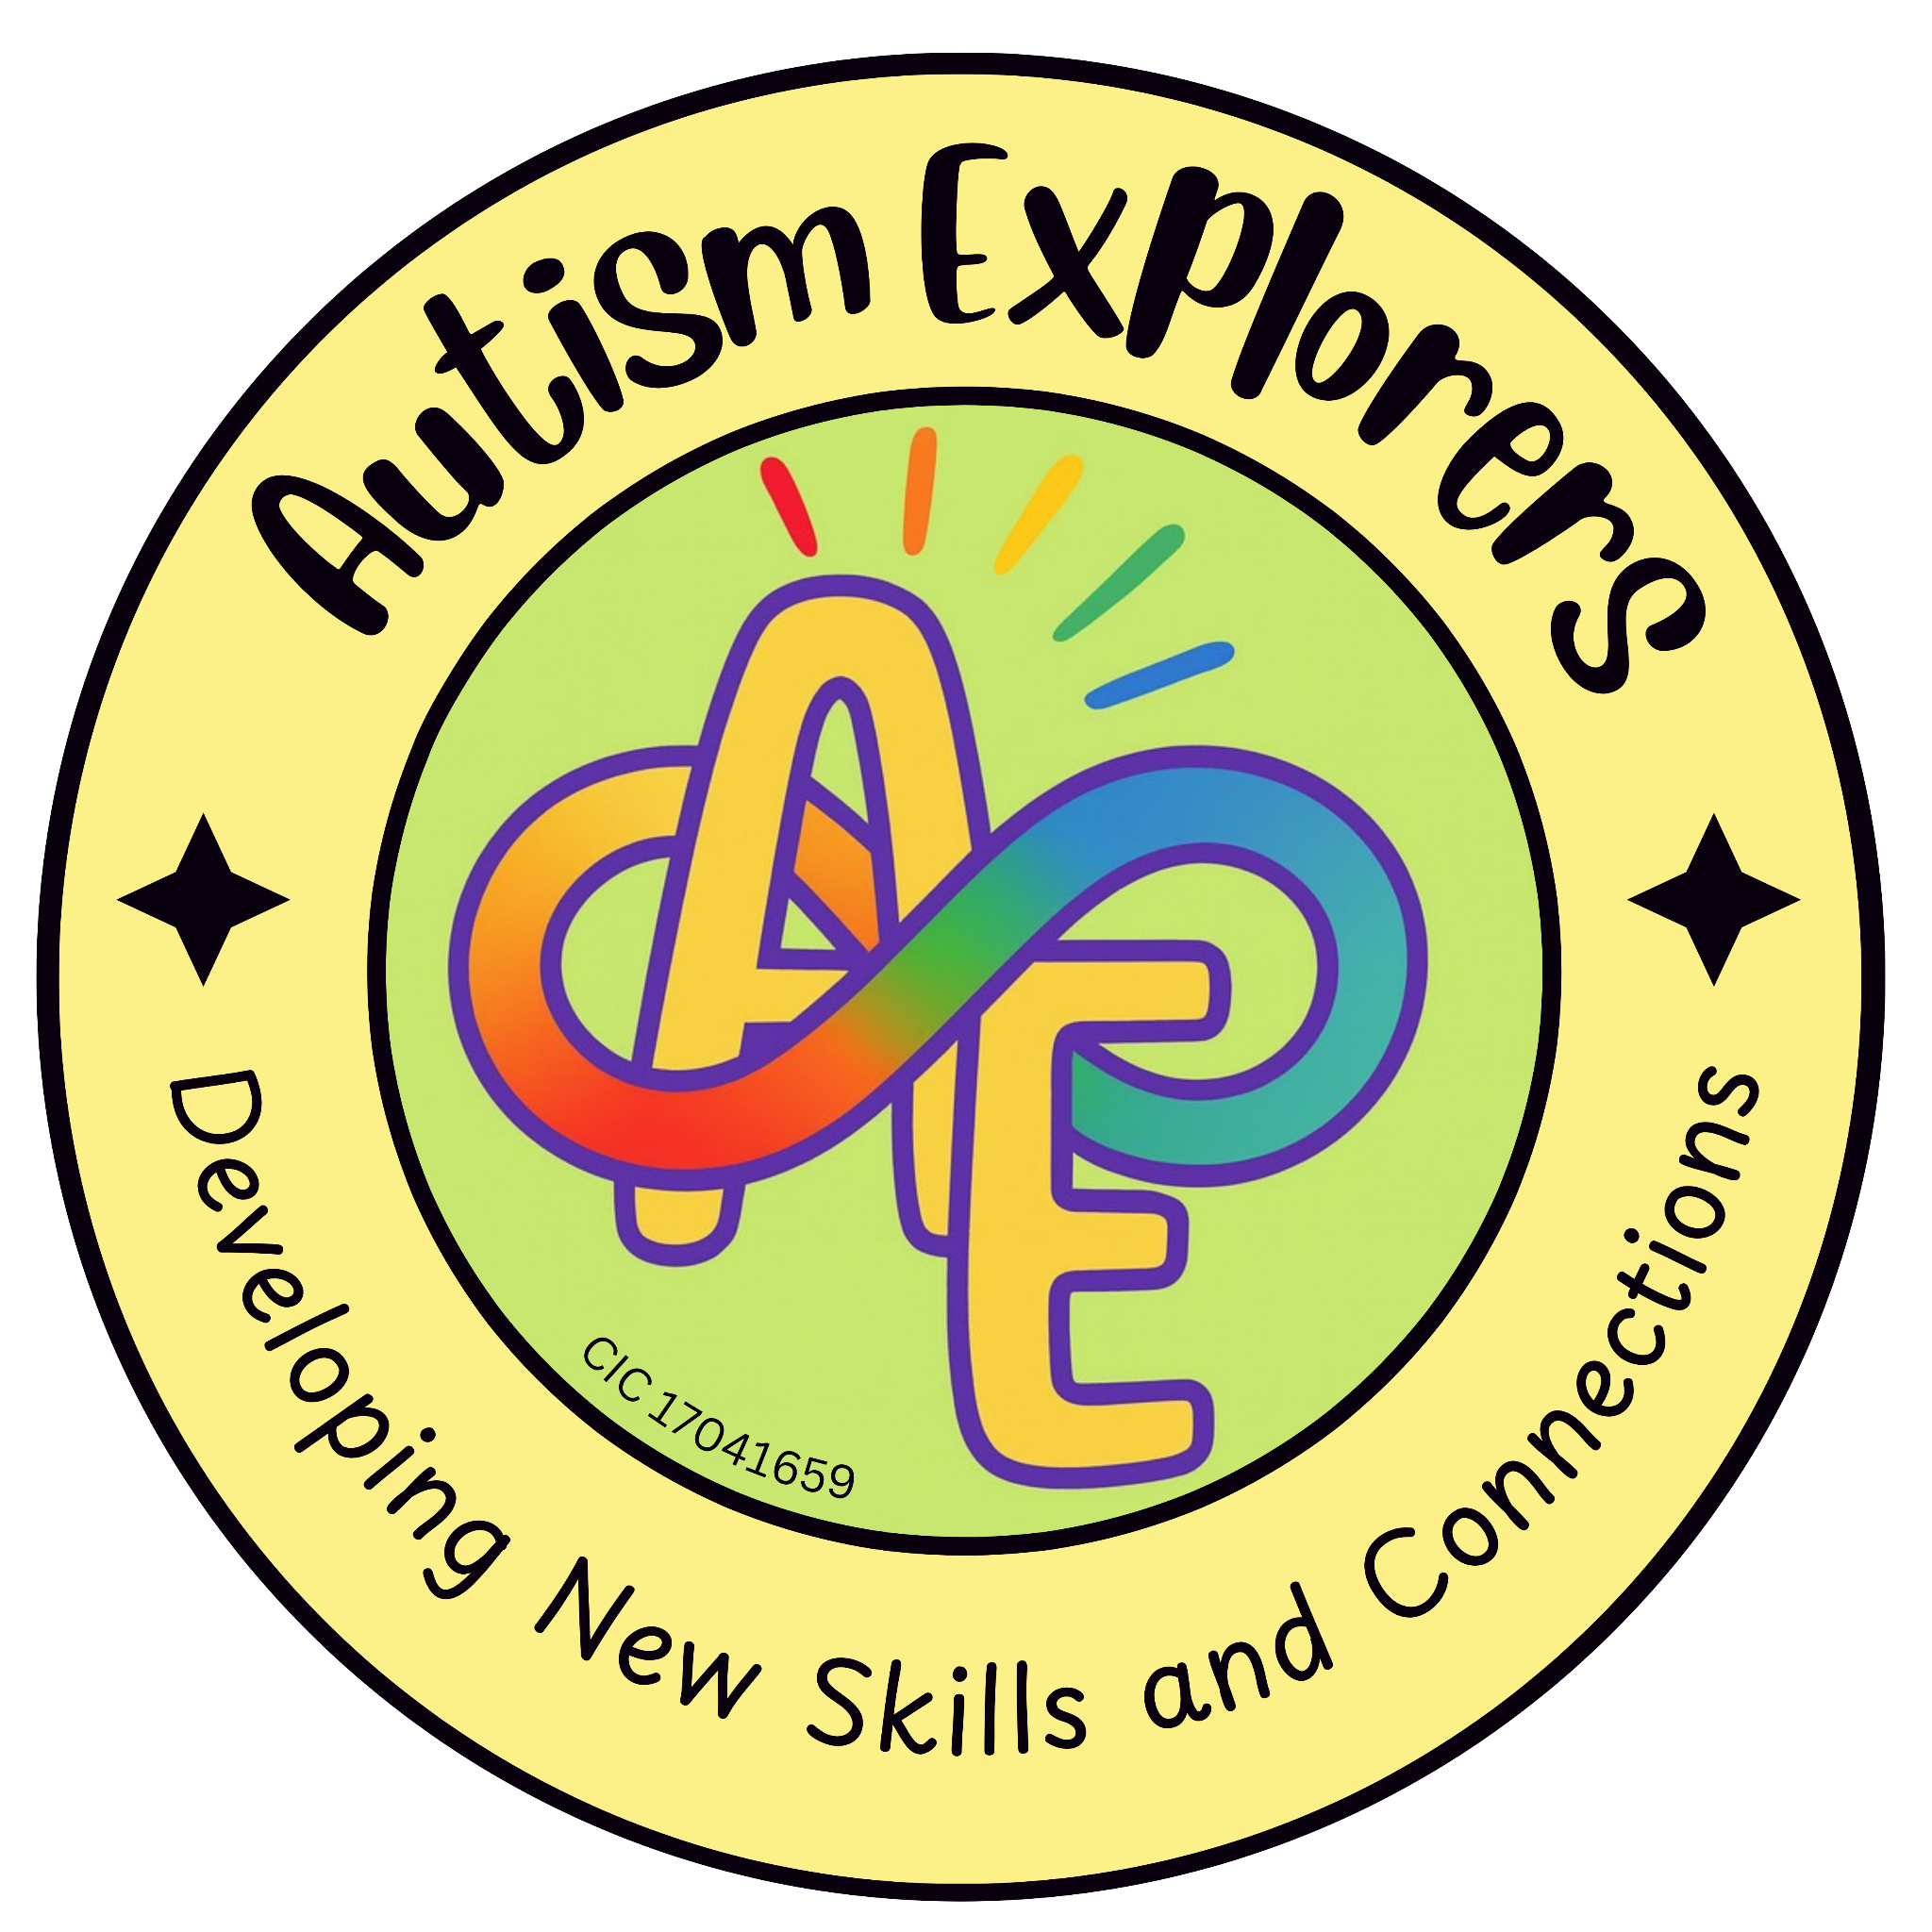

Autism Explorers CIC
Understanding and Support for All Children and Families

Autism Explorers CIC is a community group within Norfolk providing support for children with SEND and their families through; regular provisions and services such as, Sensory Saturday Stay & Plays that are child-led play, inclusive trips, events and workshops.

Understanding and Support for All Children and Families:

At Autism Explorers CIC, we provide a welcoming, non-judgemental, supportive, and inclusive environment for children with SEND and their families. We believe that a positive experience begins with a foundation of patience, empathy, and flexibility in every interaction.

We support our families through:

- Valuing Parental Expertise: We recognise that parents and carers are the experts on their own children. We value your knowledge and encourage open communication to ensure we are supporting your child in the way that works best for them.

- Sensory-Aware Environments: We understand that the physical environment can be a barrier to participation. We strive to provide sensory-friendly spaces, including access to "quiet zones" and regulated lighting/noise levels where possible, to help children feel safe and regulated.

- Reasonable Adjustments: We recognise that every child and family is unique, with different needs, experiences, and challenges. We are committed to making reasonable adjustments—such as adapting activities, providing visual schedules, or offering additional 1-1 guidance—to ensure every child can participate to their full potential.

- A "No-Judgement" Zone: We know that outings can sometimes be stressful for SEND families. Our sessions are a safe space where "behaviours that challenge" are understood as communication, and where families can feel supported rather than self-conscious.

- Holistic Support: We support the whole family, not just the child. Our team is available to offer a listening ear, share resources, and provide a community of understanding for parents and siblings alike.
Changes to our Terms and Conditions & All Other Policies
Autism Explorers CIC reserves the right to change, amend and update our terms and conditions and policies at any time.

The latest versions of all our policies will be available on our website: https://www.autismexplorersnorwich.com/ or can be sent via email with written request: helloautismexplorers@gmail.com

By booking and using our services you are agreeing to our terms and conditions.

Contact Information
Email: | Telephone:
helloautismexplorers@gmail.com | 07557220309

