Autism Explorers – Terms & Conditions

Autism Explorers CIC

Anti-Bullying, Respect & Inclusion Policy

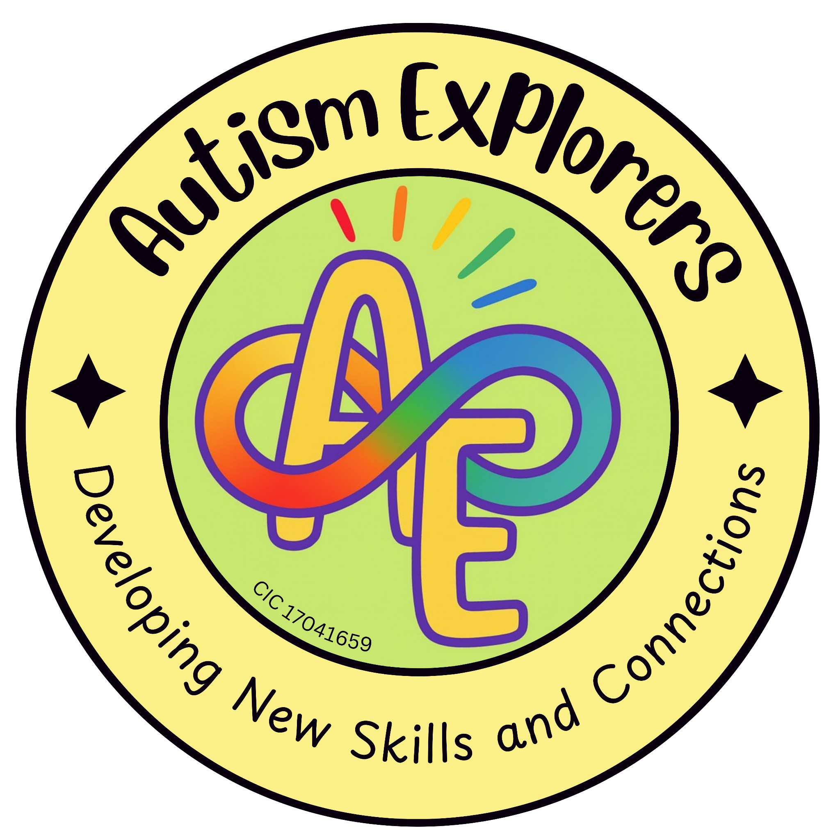

Autism Explorers CIC
Anti-Bullying, Respect & Understanding Policy

Autism Explorers CIC is a community group within Norfolk providing support for children with SEND and their families through; regular provisions and services such as, Sensory Saturday Stay & Plays that are child-led play, inclusive trips, events and workshops.

Anti-Bullying Statement:

Autism Explorers CIC has a zero-tolerance approach to bullying of any kind. This includes; physical, verbal, mental, emotional, and online bullying.

We recognise that for many children with SEND, "behaviours that challenge" are often a form of communication related to sensory overload, anxiety, or emotional dysregulation. As such:

Distinction of Intent: We distinguish between intentional bullying and distress-based reactions (meltdowns). While any behaviour causing harm will be addressed immediately to ensure safety, our response will always be trauma-informed and appropriate to the child’s developmental stage.

Peer-on-Peer Abuse: Serious or persistent bullying is recognised as a safeguarding matter and will be managed in accordance with our Child Protection & Safeguarding Policy.

Online Safety: Our zero-tolerance approach extends to the digital space, including any derogatory comments, harassment, or "outing" of families on social media or via private messaging.

Respect for Everyone:

Everyone deserves to feel safe, valued, and respected. Differences in communication, behaviour, culture, beliefs, and abilities are accepted and celebrated.

Autism Explorers CIC team members treat all children and families with kindness, compassion, and understanding. We use positive language, respect personal space and boundaries, and listen to individual needs. Any form of disrespect or disrespectful behaviour will be addressed in a prompt and sensitive manner.

Behaviours and Positive Support

We adopt a positive behaviour approach to support children with autism and additional needs. Our team aims to use calm, clear communication and provide children with access to quiet spaces for regulation when needed.

Behaviour Support Plans: Autism Explorers can assist in creating and implementing support plans tailored to a child’s specific needs. These plans can be developed at the request of a parent or carer, or may be initiated by the Autism Explorers team if they deem it necessary to ensure the child’s safety and successful participation. These plans are stored as secure documents, accessible only to team members, to ensure consistent, informed, and private support for every child.

Physical Intervention: Physical intervention will only be used with the consent of a parent, carer, or guardian, unless it is absolutely necessary as an emergency measure to prevent immediate harm to the child or others.

Shared Responsibility: Parents and carers are responsible for ensuring that the provision they book is appropriate for their child’s age and abilities. While we aim to provide a safe environment, children are expected to follow basic safety guidance provided by team members.

Partnership with Families

At Autism Explorers CIC, we provide a welcoming, non-judgemental, and inclusive environment. We promote patience, empathy, and flexibility in all interactions.
We recognise that every child and family is unique. Reasonable adjustments will be made wherever possible to help children fully participate. Parents and carers are valued partners; your expertise and knowledge of your child are always respected. If you witness or experience bullying or exclusion, we encourage you to speak openly with a member of the team.

Changes to our Terms and Conditions & All Other Policies
Autism Explorers CIC reserves the right to change, amend and update our terms and conditions and policies at any time.

The latest versions of all our policies will be available on our website: https://www.autismexplorersnorwich.com/ or can be sent via email with written request: helloautismexplorers@gmail.com

By booking and using our services you are agreeing to our terms and conditions.

Contact Information - helloautismexplorers@gmail.com Phone : 07557220309

