Autism Explorers – Terms & Conditions

Autism Explorers CIC

Photography, Video & Other Media Policy
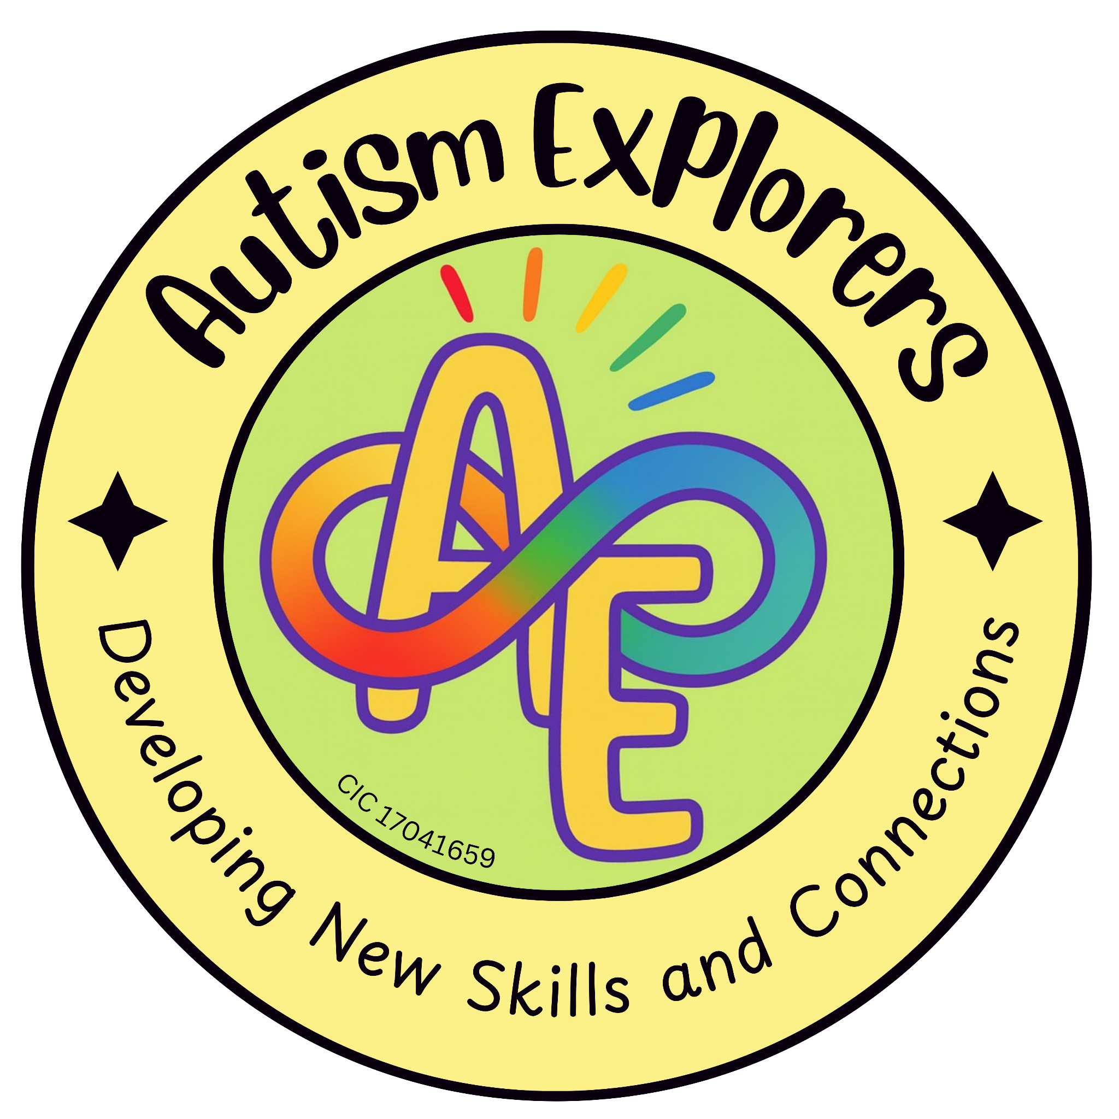

Autism Explorers CIC
Photography, Video & Other Media

Autism Explorers CIC is a community group within Norfolk providing support for children with SEND and their families through; regular provisions and services such as, Sensory Saturday Stay & Plays that are child-led play, inclusive trips, events and workshops.

Photography, Video, and Other Media:

Consent Process:

At the time of each booking, we explicitly ask for your consent regarding photography and videography. This consent must be confirmed for every session to ensure our records are always up to date.

Usage of Media:

If you provide consent, images and videos of your child may be used by

Autism Explorers CIC for:

- Social media posts and digital updates.
- Printed promotional materials (leaflets, posters, etc.).
- Our official website and advertising channels.

Third-Party Sharing:

By providing consent, you acknowledge that these images and videos may also be shared with trusted third parties to promote inclusive community activities. This includes, but is not limited to:

- Local councils and partner organisations.
- Local news outlets and community groups.
- Schools and educational partners.

Withdrawal of Consent:

You have the right to withdraw or amend your media consent at any time. If you wish to do so, please contact us via email; helloautismexplorers@gmail.com Please note that while we can remove images from our website and future social media posts, we may not be able to retract physical printed materials already in circulation.

Changes to our Terms and Conditions & All Other Policies
Autism Explorers CIC reserves the right to change, amend and update our terms and conditions and policies at any time.

The latest versions of all our policies will be available on our website: https://www.autismexplorersnorwich.com/ or can be sent via email with written request: helloautismexplorers@gmail.com

By booking and using our services you are agreeing to our terms and conditions.

Contact Information
Email: | Telephone:
helloautismexplorers@gmail.com | 07557220309

