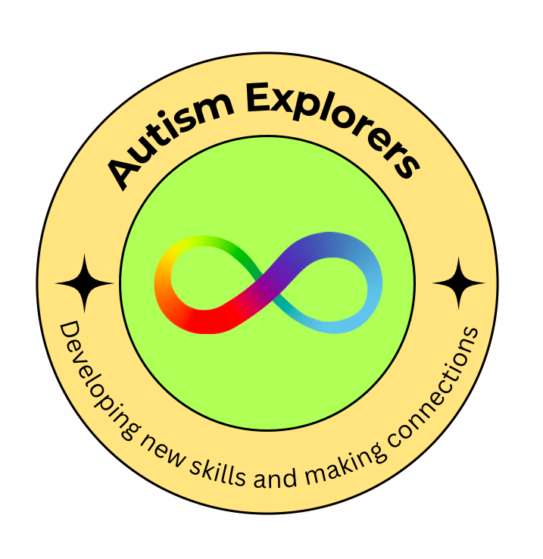
Autism Explorers – Safeguarding and Child Protection Policy
Location: Carrow House
Age Group: 3–12 Years
Last Reviewed: 02/03/2025
Next Review Due: 02/05/2025

1.

Policy Statement
Autism Explorers is committed to providing a safe, secure, and nurturing environment for all children attending our sessions.
We recognise our duty of care to protect children from harm and actively promote their welfare and wellbeing.
We are fully committed to safeguarding practices that reflect statutory responsibilities, government guidance, and best practice for working with children, particularly those with autism and additional needs.

2.

Designated Safeguarding Lead (DSL)
- Name: Lilli Forster
- Deputy DSL: Emma Forster
- The DSL has overall responsibility for safeguarding at Autism Explorers, including responding to concerns, maintaining records, and ensuring safeguarding practices are followed.

3.

Key Principles
- The welfare of the child is paramount.
- All children, regardless of age, disability, gender, racial heritage, religious belief, sexual orientation, or identity, have the right to equal protection from harm.
- Safeguarding is everyone’s responsibility.

4.

Staff and Volunteers
- All staff and volunteers are subject to safer recruitment practices, including enhanced DBS checks.
- All staff and volunteers receive regular safeguarding training appropriate to their role, including training on autism-specific safeguarding considerations.
- A minimum of two adults will be present at all times during sessions.
- Staff will always act professionally and maintain appropriate boundaries.

5.

Recognising Abuse and Responding to Concerns
Staff and volunteers are trained to recognise the signs of abuse, which may include:
- Physical abuse (unexplained injuries)
- Emotional abuse (withdrawn behaviour, sudden changes)
- Sexual abuse (age-inappropriate knowledge or behaviour)
- Neglect (hygiene concerns, lack of medical attention)
If a concern arises:
- Staff must immediately report to the Designated Safeguarding Lead.
- The DSL will assess the concern and decide on next steps, including contacting social care or the police if needed.
- Concerns are recorded factually, dated, and stored securely.
Important:
Staff must never promise confidentiality to a child if a safeguarding concern is raised.

6.

Health and Safety
- Risk assessments are carried out for all activities and premises.
- Emergency procedures (e.g., fire evacuation) are practiced regularly.
- First aid kits are available on site at all times, and staff are trained in paediatric first aid.

7.

Safer Working Practices
- Staff will avoid being alone with a child whenever possible.
- Activities will be conducted in spaces that are open and visible to others.
- Physical contact will only be appropriate, respectful, and in response to the child’s needs (e.g., comforting a distressed child).
- Use of mobile phones and personal devices is restricted during sessions.

8.

Partnership with Parents and Carers
- We aim to build trusting relationships with parents and carers, working collaboratively to support children’s wellbeing.
- Parents/carers are informed of safeguarding responsibilities upon registration.
- Where appropriate, parents/carers will be involved if a safeguarding concern arises unless doing so would place the child at greater risk.

9.

Online Safety
- Parental consent will be obtained before any photographs/videos are taken.
- Personal information about children will never be shared publicly.
- Online sessions (if any) will follow safe practice guidelines.

10.

Allegations Against Staff or Volunteers
If an allegation is made against a member of staff or a volunteer:
- It must be reported immediately to the DSL.
- The Local Authority Designated Officer (LADO) will be contacted for advice and further action.
- The individual may be suspended pending the outcome of an investigation.

11.

Whistleblowing
Staff and volunteers are encouraged to report concerns about poor or unsafe practices to the Designated Safeguarding Lead or directly to external safeguarding bodies if necessary.

Contacts
- Local Authority Designated Officer (LADO): 01603223473
- Children’s Services CADS (Norfolk): 03448008020
- Police (non-emergency): 101
- Emergency Services: 999

This policy will be reviewed annually or in response to significant changes in legislation, guidance, or incidents.

