Autism Explorers – Terms & Conditions

Autism Explorers CIC

Terms & Conditions
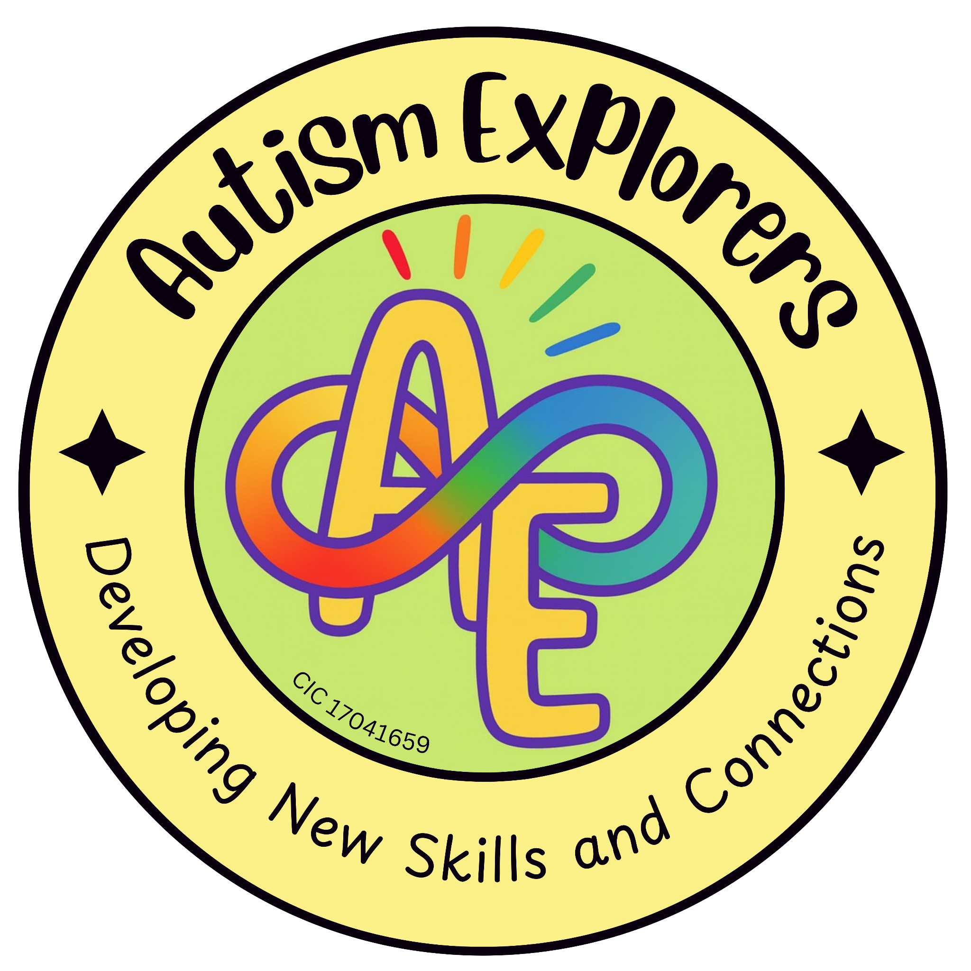

Autism Explorers CIC
Terms & Conditions

Autism Explorers CIC is a community group within Norfolk providing support for children with SEND and their families through; regular provisions and services such as, Sensory Saturday Stay & Plays that are child-led play, inclusive trips, events and workshops.
Use of Service

These Terms & Conditions are here to make sure everyone knows what to expect, so we can keep our sessions safe, fair, and enjoyable for all.

By booking and using our services you are agreeing to our terms and conditions.

Bookings, Late Bookings & Payments:

Bookings:

All bookings of Autism Explorers CIC provisions and services are to be made via our website: https://www.autismexplorersnorwich.com. If you encounter any issues when booking or whilst trying to process payment for your booking, please contact us via email: helloautismexplorers@gmail.com at your earliest convenience.

Spaces are limited and bookings are taken on a first come, first served basis. Payment in full is required to secure your booking and participation.

Late Bookings:

If a space remains on the day of the provision or service taking place, late bookings may be accepted on a first come first serve basis. Payment in full is required to secure your booking and participation.

Payments:

Payments are to be made in full at the time of booking, unless previously agreed upon in writing with both parties consenting.

If full payment has not been received within 48 hours of the initial online booking, the space(s) you have booked may be released.

Children under the age of 1 year old are free of charge, and will not need a space booking.

Financial Support:

We are aware and understand that some families may face, or already face financial barriers. There are measures in place to work alongside and support families.

Alternative payment options may include; paying on arrival, funded or discounted spaces and payment plans.

All alternative plans must be agreed upon in writing with both parties consenting, prior to your attendance of our provisions and services.

Financial support will be assessed on a case by case basis, and reviewed one month after the date stated on the financial support agreement.

If you are financial barriers, please contact us in writing about our financial support options.
Contact us via email: helloautsimexplorers@gmail.com

Cancellations & Refunds

Cancellations by you:

More than 7 days before the date of booking
You will be given the option of a full refund or a transfer of booking to another provision or session. Please note, should there be a difference in price you will be invoiced for the remaining balance.

Less than 7 days before the date of booking
Unfortunately, no refund or transfer. This is due to the venue already being hired, resources have been purchased and prepared, and your space has already been allocated.

At Autism Explorers CIC, we understand that life and neurodivergent children can be unpredictable. Our policies are designed to be fair, in exceptional circumstances and assessed on a case by case basis we may offer a 25-50% refund or a one-time transfer.

Cancellations by Autism Explorers CIC:

We apologise for the cancellation, and you will be notified of this via the email address on the booking form at the earliest opportunity.

A refund will be issued and processed the same date you receive the cancellation email on, the refund will go back into the account that was used to secure and pay for your space at the time of booking.

Please allow up to 48 hours to see the funds in your account.

Cancellations beyond our control:

If a provision and service is cancelled beyond our control (e.g. Venue needs to cancel our booking, extreme weather, etc.), we will contact you via the email address on the booking form at the earliest opportunity. We will aim to then rebook the cancelled provision and session at the earliest opportunity.

If you do not wish to be automatically rebooked, please inform us in writing via email at your earliest convenience. Following the receipt of your request, a refund will be processed. Please allow up to 48 hours to see the funds in your account.

Refunds:

Autism Explorers CIC has a refund policy in place, this applies to all of our provisions and services.

For all refunds issued and processed, please allow up to 48 hours to see the funds in your account.

In addition to the above information stated within our terms and conditions, ‘no shows’ and missed provisions and sessions will not be offered a refund or a one-time transfer unless previously agreed upon in writing with both parties consenting in exceptional circumstances.

Supervision & Responsibility:

Our Statement:

For all of our provisions and services, unless stated otherwise parents and carers must accompany their child at all times. Furthermore, parents and carers remain responsible for their child's behaviour, actions, safety and well-being for the duration of the provision and service.

Autism Explorers CIC will do everything reasonable to keep the child safe, however we cannot accept liability for accidents or incidents that occur due to lack of supervision by parents and carers. Risk assessments are done during the planning process, as well as the morning of provision and service taking place.

Responsibility:

Parents and carers are responsible for ensuring that the provisions, sessions, or activities they book are suitable for their child’s age, abilities, needs, and level of support required. This helps ensure that children can participate safely and benefit from the activities provided.

Autism Explorers CIC aims to provide a safe, inclusive, and supportive environment for all participants. Children are expected to follow reasonable safety guidance and instructions given by team members during sessions and activities.

Outdoor Play and Activities:

May take place during our provisions and sessions where appropriate, however, these are dependent on weather conditions. Parents and carers are kindly asked that children are dressed appropriately for the weather and suitable for outdoor activities.

Food & Drink:

Parents and carers are responsible for informing Autism Explorers CIC of any food allergies, intolerances or dietary requirements their child may have. Where children bring their own food or snacks, parents and carers must ensure these are appropriate and safe for their child.

Drinks and snacks provided by Autism Explorers CIC during provisions and sessions, will be appropriate for children. However, Autism Explorers CIC cannot guarantee a completely allergen-free environment.

Clothing and Personal Belongings:

Children should attend sessions wearing appropriate clothing and footwear for both indoor and outdoor activities. This may include weather-appropriate clothing such as coats, waterproofs, sun hats, or warm layers depending on the season.

Autism Explorers CIC cannot accept responsibility for lost, damaged, or misplaced personal belongings, so we recommend that valuable items are not brought to sessions.

Responsibility within Health & Safety:

Parents and carers are responsible for informing a member of the Autism Explorers CIC team if their child has specific needs that may require reasonable adjustment.

‘Resources and equipment have been carefully chosen by the Autism Explorers CIC team members for safety and suitability. Should your child have specific needs that may require reasonable adjustments please let us know at your earliest convenience.’ - Quoted from the Autism Explorers CIC: Health & Safety Policy, last updated in March 2026.

Parents and carers are responsible for informing a member of the Autism Explorers CIC team if their child has a medical condition and any relevant medication.

‘Parents and carers responsible for the child must inform a first aid trained Autism Explorers CIC team member upon arrival to the provisions and sessions if their child has any medical conditions. This ensures that the appropriate first aid can be administered and assistance with medication can be provided if necessary.’ - Quoted from the Autism Explorers CIC: Health & Safety Policy, last updated in March 2026.

Parents and carers are responsible for ensuring that their child is well enough to participate, and being mindful of their symptoms.

‘Autism Explorers CIC kindly asks that any child showing signs of sickness or illness (e.g. fever, vomiting, diarrhoea, etc.) does not attend their booked/scheduled provision and session. This helps to reduce the risk of or prevent the spread of sickness or illness to the other children, parents, carers and team members.

Some of the children who attend our provisions and services may have underlying medical conditions or a weakened immune system, which can make them more vulnerable to infections. For this we ask families to be mindful of symptoms and only attend provisions and sessions when children are well enough to participate.’ - Quoted from the Autism Explorers CIC: Health & Safety Policy, last updated in March 2026.

Parents and carers must provide up-to-date emergency contact information relevant to their child.

Health & Safety:

Our Statement:

At Autism Explorers CIC, we take the health and safety of our attendees seriously. We are committed to ensuring the health, safety & welfare of all children who attend our provisions and services. The Autism Explorers CIC team is dedicated to creating a safe and supportive environment where children with SEND can participate in activities and learn, free from harm or injury. This policy sets out the health & safety procedures that everyone must adhere to ensure the safe operation of all activities.

Risk Assessments:

Thorough risk assessments are carried out during the planning process, as well as the morning of the provision and service taking place, this is to identify and address any potential hazards. Our risk assessments included but are not limited to; venue, activities, equipment, indoor and outdoor spaces.

Should risk assessments need to be revisited during any provisions or sessions this will be done at the earliest opportunity. In particular when any changes are made to the activities, equipment, group dynamics or weather related changes.

Furthermore, during the planning process specific health and safety considerations for children with SEND are taken into account.

Resources and equipment have been carefully chosen by the Autism Explorers CIC team members for safety and suitability. Should your child have specific needs that may require reasonable adjustments please let us know at your earliest convenience.

Our regular venue: Jubilee Community Centre, Long John Hill, Norwich, NR12EX has toilets, a kitchen, access to outdoor spaces and public areas. We expect parents and carers to supervise their child at all times. Especially if there is access to hot water, gates to outdoor and public areas.

Responsibilities within Health & Safety:

Parents and Carers:

Parents and carers responsible for the child must inform a first aid trained Autism Explorers CIC team member upon arrival to the provisions and sessions if their child has any medical conditions. This ensures that the appropriate first aid can be administered and assistance with medication can be provided if necessary.

Parents and carers must provide up-to-date emergency contact information relevant to their child.

Autism Explorers CIC Team Members:

All Autism Explorers CIC team members will be aware of and comply with the health & safety policies and procedures that are in place, as well as the policies and procedures of our regular venue: Jubilee Community Centre, Long John Hill, Norwich, NR12EX.

The team members will also ensure that all children are safely supervised and supported at all times by their parents and carer.

It is the duty of the Designated Safeguarding Lead (DSL) Lillian Forster and Deputy Designated Safeguarding Lead (Deputy DSL) Emma Forster to ensure that all team members have a relevant and up-to-date DBS and safeguarding training.

There are regular training and learning opportunities for all Autism Explorers CIC team members, ensuring up-to-date knowledge and skills in health and safety, first aid, safeguarding, autism, and SEN-specific needs and behaviours.

For our regular venue: Jubilee Community Centre, Long John Hill, Norwich, NR12EX.
Checks of fire exits and evacuation routes will be checked before each provision and session, and they must be kept clear and free from obstruction at all times.

All Autism Explorers CIC team members are aware of the fire exits, evacuation routes and meeting points in case of an evacuation.

Hygiene, Sanitation and Cleanliness:

Hygiene:

Children are encouraged to wash their hands before snack time and after outdoor play, to promote good hygiene and stop the spread of germs.

Sanitation:

Our regular venue: Jubilee Community Centre, Long John Hill, Norwich, NR12EX hires their own cleaner for a full clean of the entire venue once a week.

In addition to this Autism Explorers CIC team members are responsible for the cleanliness before and after our provisions and sessions. This is to ensure that all surfaces, equipment, materials, etc. are safe and hygienic for all to use. Furthermore, ensuring that our regular venue: Jubilee Community Centre, Long John Hill, Norwich, NR12EX is kept clean, tidy and free from hazards before, during and after our provisions and sessions.

Particular care and attention is given to maintaining high standards of hygiene in shared spaces (e.g. toilets) and activity areas (e.g. main hall, tables, chairs, tuff trays)

Sickness and Illness:
Autism Explorers CIC kindly asks that any child showing signs of sickness or illness (e.g. fever, vomiting, diarrhoea, etc.) does not attend their booked/scheduled provision and session. This helps to reduce the risk of or prevent the spread of sickness or illness to the other children, parents, carers and team members.

Some of the children who attend our provisions and services may have underlying medical conditions or a weakened immune system, which can make them more vulnerable to infections. For this we ask families to be mindful of symptoms and only attend provisions and sessions when children are well enough to participate.

Child Protection & Safeguarding Statement:
Autism Explorers CIC is committed to providing a safe, secure and nurturing environment for all children, families and visitors who attend our provisions and sessions.

Our child protection and safeguarding policy and practices reflect statutory responsibilities, government guidance, and best practices for working with children, particularly those with autism and additional needs. We recognise our duty of care to protect children from harm and actively promote their welfare and wellbeing.

Designated Safeguarding Team:
The Designated Safeguarding Lead (DSL) has overall responsibility for safeguarding at Autism Explorers CIC, including reporting concerns, maintaining records, and ensuring policies are followed.

Designated Safeguarding Lead  (DSL) | Lillian Forster
Deputy Designated Safeguarding Lead (Deputy DSL) | Emma Forster

Partnership with Families
At Autism Explorers CIC, we provide a welcoming, non-judgemental, and inclusive environment. We promote patience, empathy, and flexibility in all interactions.
We recognise that every child and family is unique. Reasonable adjustments will be made wherever possible to help children fully participate. Parents and carers are valued partners; your expertise and knowledge of your child are always respected. If you witness or experience bullying or exclusion, we encourage you to speak openly with a member of the team.

Privacy & Data Protection:
We only collect and securely store personal data relevant to the safe and effective running of our provisions and services.

This data typically includes:

- Child’s Details: Name, age, and specific support or medical needs.

- Parent and Carer Details: Name, contact telephone number, and email address.

- Emergency Contact Information: To ensure safety during sessions.

- Data Retention & Security: Personal data is stored securely and will only be kept for as long as is necessary to fulfil the purposes for which it was collected, or as required by insurance and safeguarding regulations.

- Confidentiality & Third Parties: Your data is treated with the strictest confidentiality. It will not be shared with third parties without your prior written consent, unless we are legally required to do so (e.g., in the event of a safeguarding concern or a medical emergency).

- Marketing & Subscriptions: If you have signed up for updates, subscriptions, or our marketing mailing list, we will use your data for these purposes until you choose to unsubscribe. You have the right to withdraw your consent at any time by clicking the "unsubscribe" link in our emails or contacting us directly.

Your Rights: Under UK GDPR, you have the right to request access to the personal data we hold about you, the right to have any inaccuracies corrected, and the right to request the deletion of your data (where applicable).

Photography, Video, and Other Media:

Consent Process: At the time of each booking, we explicitly ask for your consent regarding photography and videography. This consent must be confirmed for every session to ensure our records are always up to date.

Usage of Media: If you provide consent, images and videos of your child may be used by

Autism Explorers CIC for:
- Social media posts and digital updates.
- Printed promotional materials (leaflets, posters, etc.).
- Our official website and advertising channels.

Third-Party Sharing: By providing consent, you acknowledge that these images and videos may also be shared with trusted third parties to promote inclusive community activities. This includes, but is not limited to:

- Local councils and partner organisations.
- Local news outlets and community groups.
- Schools and educational partners.

Withdrawal of Consent: You have the right to withdraw or amend your media consent at any time. If you wish to do so, please contact us via email; helloautismexplorers@gmail.com Please note that while we can remove images from our website and future social media posts, we may not be able to retract physical printed materials already in circulation.

Intellectual Property Rights & Copyright

All content created by Autism Explorers CIC, including but not limited to; resources, written materials and activity plans, website content, newsletters, logos, graphics, flyers, posters, leaflets, images and videos are protected under the Copyright, Designs and Patents Act 1988.

Unless stated otherwise in writing, all intellectual property rights belong solely to Autism Explorers CIC.

Permitted Use:

You may view, share and use Autism Explorers CIC materials for personal or educational purposes only (e.g. copying or gaining inspiration from an activity from a Sensory Saturday session to use at home or in a school setting with credit back to Autism Explorers CIC).

Prohibited Use:

You may not; copy, reproduce or redistribute our materials, resources or branding for commercial use or gain. without prior written consent, approval and permission in writing from Autism Explorers CIC.

Further prohibited use covers Autism Explorers CIC’s; name, logo, brand identity for advertising, training or services not associated with Autism Explorers CIC.

Requesting Permission:

If you wish to use Autism Explorers resources, written materials and activity plans, website content, newsletters, logos, graphics, flyers, posters, leaflets, images and videos, you must contact us in writing via email for approval.

Changes to our Terms and Conditions & All Other Policies
Autism Explorers CIC reserves the right to change, amend and update our terms and conditions and policies at any time.

The latest versions of all our policies will be available on our website: https://www.autismexplorersnorwich.com/ or can be sent via email with written request: helloautismexplorers@gmail.com

By booking and using our services you are agreeing to our terms and conditions.

Contact Information
Email; helloautismexplorers@gmail.com | Telephone: 07557220309

