Autism Explorers – Terms & Conditions

Autism Explorers CIC

Health & Safety Policy

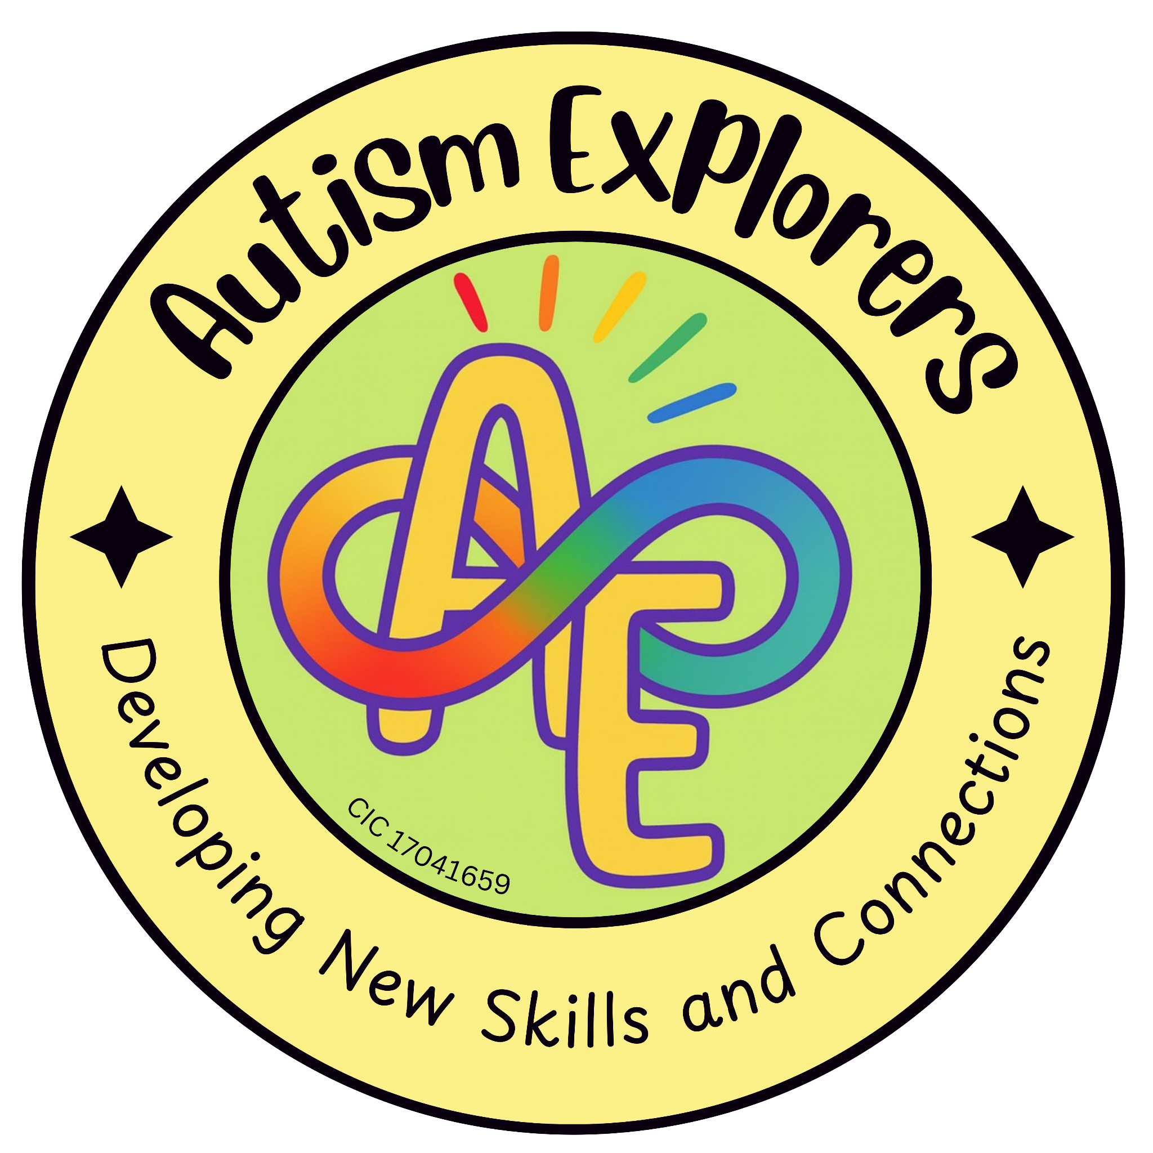

Autism Explorers CIC
Health & Safety

Autism Explorers CIC is a community group within Norfolk providing support for children with SEND and their families through; regular provisions and services such as, Sensory Saturday Stay & Plays that are child-led play, inclusive trips, events and workshops.

Health & Safety:

Our Statement:

At Autism Explorers CIC, we take the health and safety of our attendees seriously. We are committed to ensuring the health, safety & welfare of all children who attend our provisions and services. The Autism Explorers CIC team is dedicated to creating a safe and supportive environment where children with SEND can participate in activities and learn, free from harm or injury. This policy sets out the health & safety procedures that everyone must adhere to ensure the safe operation of all activities.

Risk Assessments:

Thorough risk assessments are carried out during the planning process, as well as the morning of the provision and service taking place, this is to identify and address any potential hazards. Our risk assessments included but are not limited to; venue, activities, equipment, indoor and outdoor spaces.

Should risk assessments need to be revisited during any provisions or sessions this will be done at the earliest opportunity. In particular when any changes are made to the activities, equipment, group dynamics or weather related changes.

Furthermore, during the planning process specific health and safety considerations for children with SEND are taken into account.

Resources and equipment have been carefully chosen by the Autism Explorers CIC team members for safety and suitability. Should your child have specific needs that may require reasonable adjustments please let us know at your earliest convenience.

Our regular venue: Jubilee Community Centre, Long John Hill, Norwich, NR12EX has toilets, a kitchen, access to outdoor spaces and public areas. We expect parents and carers to supervise their child at all times. Especially if there is access to hot water, gates to outdoor and public areas.

Responsibilities within Health & Safety:

Parents and Carers:

Parents and carers responsible for the child must inform a first aid trained Autism Explorers CIC team member upon arrival to the provisions and sessions if their child has any medical conditions. This ensures that the appropriate first aid can be administered and assistance with medication can be provided if necessary.

Parents and carers must provide up-to-date emergency contact information relevant to their child.

Autism Explorers CIC Team Members:

All Autism Explorers CIC team members will be aware of and comply with the health & safety policies and procedures that are in place, as well as the policies and procedures of our regular venue: Jubilee Community Centre, Long John Hill, Norwich, NR12EX.

The team members will also ensure that all children are safely supervised and supported at all times by their parents and carer.

It is the duty of the Designated Safeguarding Lead (DSL) Lillian Forster and Deputy Designated Safeguarding Lead (Deputy DSL) Emma Forster to ensure that all team members have a relevant and up-to-date DBS and safeguarding training.

There are regular training and learning opportunities for all Autism Explorers CIC team members, ensuring up-to-date knowledge and skills in health and safety, first aid, safeguarding, autism, and SEN-specific needs and behaviours.

For our regular venue: Jubilee Community Centre, Long John Hill, Norwich, NR12EX.
Checks of fire exits and evacuation routes will be checked before each provision and session, and they must be kept clear and free from obstruction at all times.

All Autism Explorers CIC team members are aware of the fire exits, evacuation routes and meeting points in case of an evacuation.

First Aid & First Aid Kits:

First Aid:

There will be a minimum of one first aid trained Autism Explorers CIC team member present at all of our provisions & sessions.

In the event of injury first aid will be administered with the consent and permission from the parent and carer responsible for the child during the provision and session. Following this an accident, incident and injury form will be completed.

First Aid Kits:

Autism Explorers CIC first aid kits are checked once a month.

Medical Emergencies, Emergency Procedures & Evacuations:

Medical Emergencies:

In the event of a medical emergency, or if further emergency medical treatment is needed, the relevant services and authorities will be contacted. The child will be taken to the nearest hospital, unless the parent and carer has stated otherwise to the emergency services.

Evacuations:

In the event of an emergency, we will follow the evacuation procedures set out by the hosting venue and follow all safety measures as well. Members of the Autism Explorers CIC team will safely guide all children, parents, carers and visitors to the designated assembly point.

Upon arrival at the designated assembly point, Autism Explorers CIC fire marshal or designated safeguarding lead will conduct a formal headcount against the dates provision and service register. This headcount will be double checked to ensure that no child has been left behind or is unaccounted for.

In the event that a child is unaccounted for during the formal headcount, the responsible parent and carer must notify the fire marshal or designated safeguarding lead immediately.

Reporting Accidents, Incidents & Injuries:

All accidents, incidents and injuries must be reported immediately. Relevant paperwork will be filled in by a member of the Autism Explorers CIC team.

A record will be kept including but not limited to; who was involved, details of what happened from the relevant parties involved and any witnesses, if first aid was administered and if any further action needs to be taken.

All accident, incident and injury forms will be reviewed by the Designated Safeguarding Lead (DSL) Lillian Forster or Deputy Designated Safeguarding Lead (Deputy DSL) Emma Forster.

If required and necessary the appropriate and relevant local authorities and services will be notified.

Hygiene, Sanitation and Cleanliness:

Hygiene:

Children are encouraged to wash their hands before snack time and after outdoor play, to promote good hygiene and stop the spread of germs.

Sanitation:

Our regular venue: Jubilee Community Centre, Long John Hill, Norwich, NR12EX hires their own cleaner for a full clean of the entire venue once a week.

In addition to this Autism Explorers CIC team members are responsible for the cleanliness before and after our provisions and sessions. This is to ensure that all surfaces, equipment, materials, etc. are safe and hygienic for all to use. Furthermore, ensuring that our regular venue: Jubilee Community Centre, Long John Hill, Norwich, NR12EX is kept clean, tidy and free from hazards before, during and after our provisions and sessions.

Particular care and attention is given to maintaining high standards of hygiene in shared spaces (e.g. toilets) and activity areas (e.g. main hall, tables, chairs, tuff trays)

Sickness and Illness:

Autism Explorers CIC kindly asks that any child showing signs of sickness or illness (e.g. fever, vomiting, diarrhoea, etc.) does not attend their booked/scheduled provision and session. This helps to reduce the risk of or prevent the spread of sickness or illness to the other children, parents, carers and team members.

Some of the children who attend our provisions and services may have underlying medical conditions or a weakened immune system, which can make them more vulnerable to infections. For this we ask families to be mindful of symptoms and only attend provisions and sessions when children are well enough to participate.

Changes to our Terms and Conditions & All Other Policies

Autism Explorers CIC reserves the right to change, amend and update our terms and conditions and policies at any time.

The latest versions of all our policies will be available on our website: https://www.autismexplorersnorwich.com/ or can be sent via email with written request: helloautismexplorers@gmail.com

By booking and using our services you are agreeing to our terms and conditions.

Contact Information
Email: | Telephone:
helloautismexplorers@gmail.com | 07557220309

