Autism Explorers – Terms & Conditions

Autism Explorers CIC

Feedback & Reviews Policy

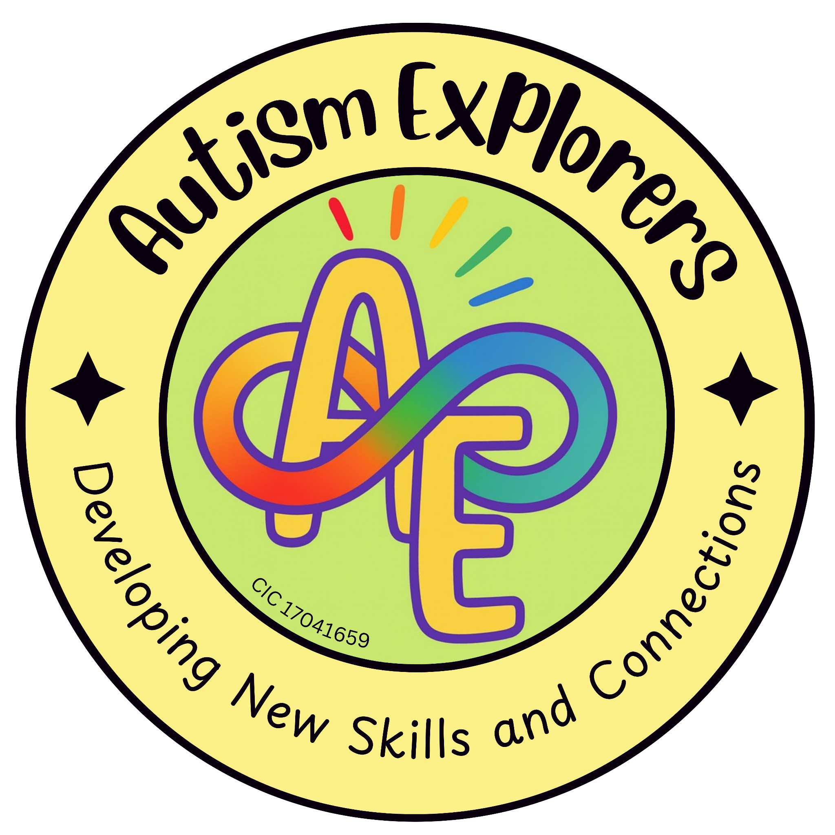

Autism Explorers CIC
Reviews & Feedback

Autism Explorers CIC is a community group within Norfolk providing support for children with SEND and their families through; regular provisions and services such as, Sensory Saturday Stay & Plays that are child-led play, inclusive trips, events and workshops.

Feedback & Reviews:
We value your input and love to hear about your experiences with our services. If you would like to leave feedback:

Website:

Visit our website and use the ‘Leave a Comment’ box at the bottom of the page.

Social Media:

Leave a review on our official Facebook page.

Direct Message:

Alternatively, you can message us privately. With your explicit consent, we can share your feedback on our platforms on your behalf.

Changes to our Terms and Conditions & Policies

Autism Explorers reserves the right to change, amend and update our terms and conditions and policies at any time.

The latest versions will always be available on our website https://www.autismexplorersnorwich.com/ or by written request via email.

By booking and using our services you are agreeing to our terms and conditions.

Contact Information
Email: | Telephone:
helloautismexplorers@gmail.com | 07557220309

