Autism Explorers – Terms & Conditions

Autism Explorers CIC

Privacy & Data Protection Policy
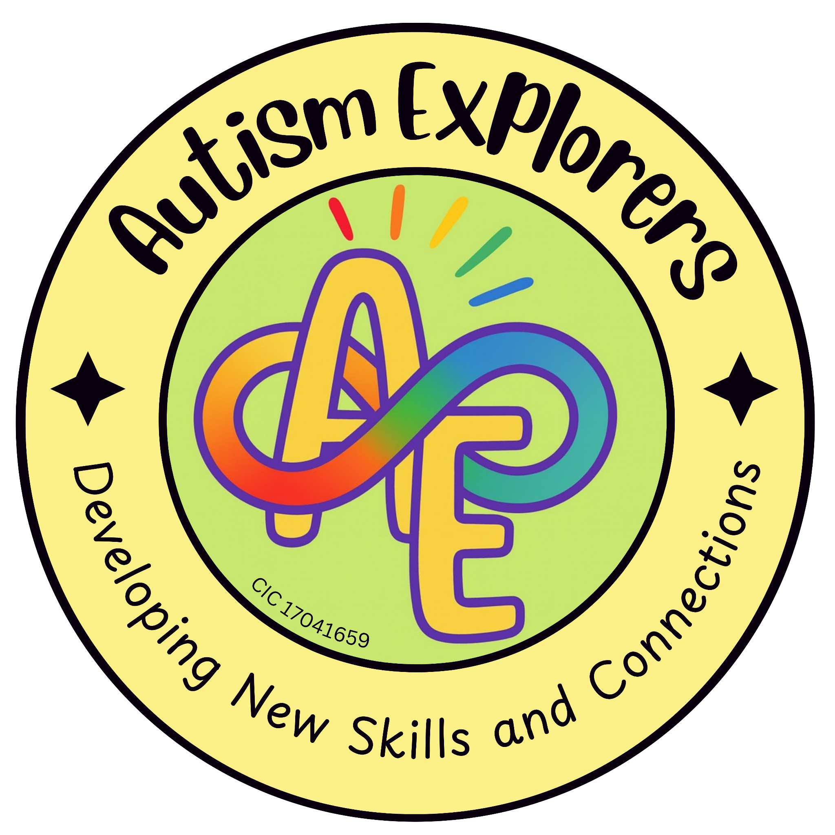

Autism Explorers CIC
Privacy & Data Protection

Autism Explorers CIC is a community group within Norfolk providing support for children with SEND and their families through; regular provisions and services such as, Sensory Saturday Stay & Plays that are child-led play, inclusive trips, events and workshops.

Privacy & Data Protection:
We only collect and securely store personal data relevant to the safe and effective running of our provisions and services.

This data typically includes:

- Child’s Details: Name, age, and specific support or medical needs.

- Parent and Carer Details: Name, contact telephone number, and email address.

- Emergency Contact Information: To ensure safety during sessions.

- Data Retention & Security: Personal data is stored securely and will only be kept for as long as is necessary to fulfil the purposes for which it was collected, or as required by insurance and safeguarding regulations.

- Confidentiality & Third Parties: Your data is treated with the strictest confidentiality. It will not be shared with third parties without your prior written consent, unless we are legally required to do so (e.g., in the event of a safeguarding concern or a medical emergency).

- Marketing & Subscriptions: If you have signed up for updates, subscriptions, or our marketing mailing list, we will use your data for these purposes until you choose to unsubscribe. You have the right to withdraw your consent at any time by clicking the "unsubscribe" link in our emails or contacting us directly.

Your Rights: Under UK GDPR, you have the right to request access to the personal data we hold about you, the right to have any inaccuracies corrected, and the right to request the deletion of your data (where applicable).

Changes to our Terms and Conditions & All Other Policies
Autism Explorers CIC reserves the right to change, amend and update our terms and conditions and policies at any time.

The latest versions of all our policies will be available on our website: https://www.autismexplorersnorwich.com/ or can be sent via email with written request: helloautismexplorers@gmail.com

By booking and using our services you are agreeing to our terms and conditions.

Contact Information
Email: | Telephone:
helloautismexplorers@gmail.com | 07557220309

