Autism Explorers – Terms & Conditions

Autism Explorers CIC

Child Protection & Safeguarding Policy

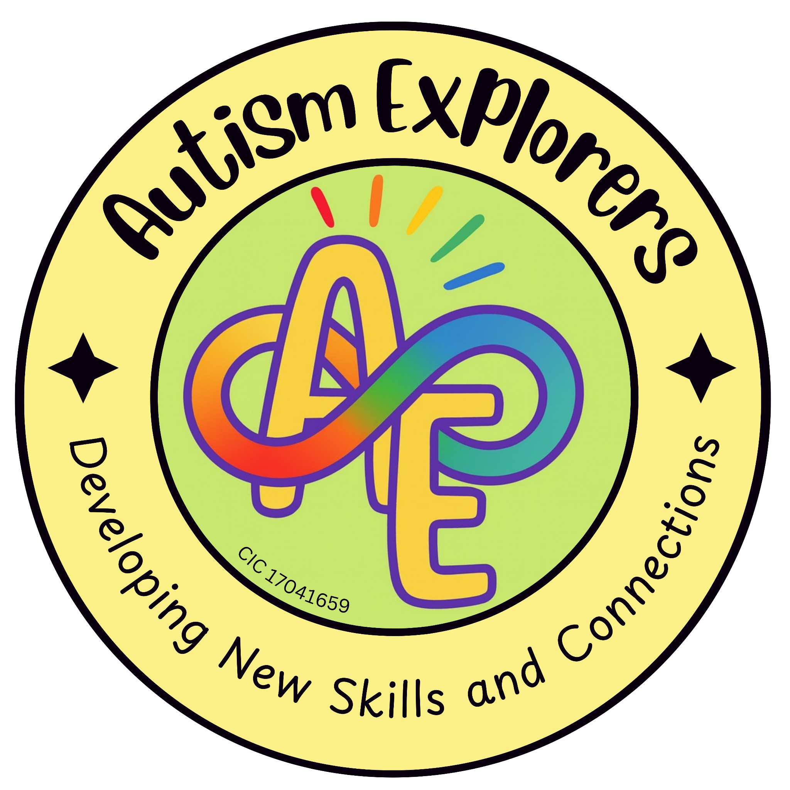

Autism Explorers CIC
Child Protection & Safeguarding

Autism Explorers CIC is a community group within Norfolk providing support for children with SEND and their families through; regular provisions and services such as, Sensory Saturday Stay & Plays that are child-led play, inclusive trips, events and workshops.

Child Protection & Safeguarding Statement:
Autism Explorers CIC is committed to providing a safe, secure and nurturing environment for all children, families and visitors who attend our provisions and sessions.

Our child protection and safeguarding policy and practices reflect statutory responsibilities, government guidance, and best practices for working with children, particularly those with autism and additional needs. We recognise our duty of care to protect children from harm and actively promote their welfare and wellbeing.

Designated Safeguarding Team:
The Designated Safeguarding Lead (DSL) has overall responsibility for safeguarding at Autism Explorers CIC, including reporting concerns, maintaining records, and ensuring policies are followed.

Designated Safeguarding Lead  (DSL) | Lillian Forster
Deputy Designated Safeguarding Lead (Deputy DSL) | Emma Forster

Team Members Standards and Training:

All Autism Explorers CIC team members are subject to safer recruitment practices, including enhanced DBS checks.

Our team maintains professional boundaries at all times and adheres to the following:
- Training: In child protection, including autism-specific safeguarding concerns and identifying signs of distress in non-verbal or minimally verbal children.
- Supervision: A minimum of one team member will be present at every session.
- Safety Credentials: At least one team member present will be First Aid trained.
- Key Principles:

The welfare of the child is paramount.

All children, regardless of age, disability, gender, racial heritage, religious belief, sexual orientation, or identity, have the right to equal protection from harm.

Communication Advocacy:
We recognise that autistic children may face increased barriers to reporting abuse. We are committed to "listening" to all forms of communication, including behaviour, emotional shifts, and sensory changes.

Recognising Abuse and Responding to Concerns:
Autism Explorers CIC team members are trained to recognise signs of abuse, including physical, emotional, mental, sexual and neglect.

Given our demographic, we pay specific attention to:
- Regression: Sudden loss of previously mastered skills.
- Behavioural Shifts: Increased self-injury, extreme withdrawal, or unexplained aggression.
- Sensory Changes: New or heightened sensitivities that may indicate trauma.

Reporting Procedure:

Report: Concerns must be reported immediately to the Designated Safeguarding Lead (DSL) or Deputy Designated Safeguarding Lead (Deputy DSL)

Assess: The Designated Safeguarding Lead (DSL) will assess the concern and decide on the next steps, including contacting local authorities if required.

Record: All concerns are recorded with relevant details, dated, and stored securely in accordance with GDPR and the Data Protection Act 2018.

IMPORTANT NOTICE: Autism Explorers CIC team members must never promise confidentiality to a child if a safeguarding concern is raised.

Online Safety & Data Privacy:

Consent:

Explicit consent is obtained via booking forms before any photographs, videos, or media are taken. This must be updated for every booking.

Public Sharing:

Personal information about a child will never be shared publicly or on social media without specific, documented permission.

Allegations & Whistleblowing:

Allegations against Staff:

Any allegation made against a team member must be reported immediately to the Designated Safeguarding Lead (DSL) or Deputy Designated Safeguarding Lead (Deputy DSL).

The Local Authority Designated Officer (LADO) will be contacted for advice and further action. The individual may be suspended pending the outcome of an investigation.

Whistleblowing:

All Autism Explorers team members are encouraged to report concerns regarding poor or unsafe practices without fear of repercussion. Reports should be made to the Designated Safeguarding Lead (DSL) or Deputy Designated Safeguarding Lead (Deputy DSL).

If the concern involves the Designated Safeguarding Lead (DSL), or if a team member feels the organisation is not acting appropriately, they should contact the LADO or external safeguarding authorities directly.

Physical Intervention & Environment:

Autism Explorers operates a proactive approach to safety:

Restrictive Intervention:

We do not use restrictive physical intervention unless there is an immediate risk of significant harm to the child or others.

Risk Assessments:

All venues undergo rigorous risk assessments to ensure they are sensory-safe and secure (e.g., minimising risks of "bolting" or sensory overload).

Local Authority and Services Contact Information:

Authority | Contact Number
LADO (Local Authority Designated Officer) | 01603 223473
Children’s Services CADS - Norfolk | 0344 800 8020
Emergency Services | 101
Police Non-Emergency | 999

Changes to our Terms and Conditions & All Other Policies

Autism Explorers CIC reserves the right to change, amend and update our terms and conditions and policies at any time.

The latest versions of all our policies will be available on our website: https://www.autismexplorersnorwich.com/ or can be sent via email with written request: helloautismexplorers@gmail.com

By booking and using our services you are agreeing to our terms and conditions.

Contact Information
Email: | Telephone:
helloautismexplorers@gmail.com | 07557220309

